**SPRINT-1**

|  |  |
| --- | --- |
| **Date** | 19 NOVEMBER 2022 |
| **Team ID** | PNT2022TMID36291 |
| **Project Name** | SMART SOLUTIONS FOR RAILWAYS |

**PROCEDURE:**

Srep1: Develop node red application

Step2: Install the required nodes from manage palette option

Step3: Connect the node flow

Step4: Deploy the flow

**WEB APPLICATION :**

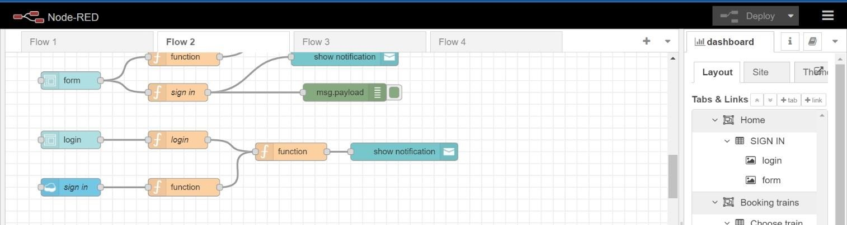

**NODES TO BOOK TRAIN:**

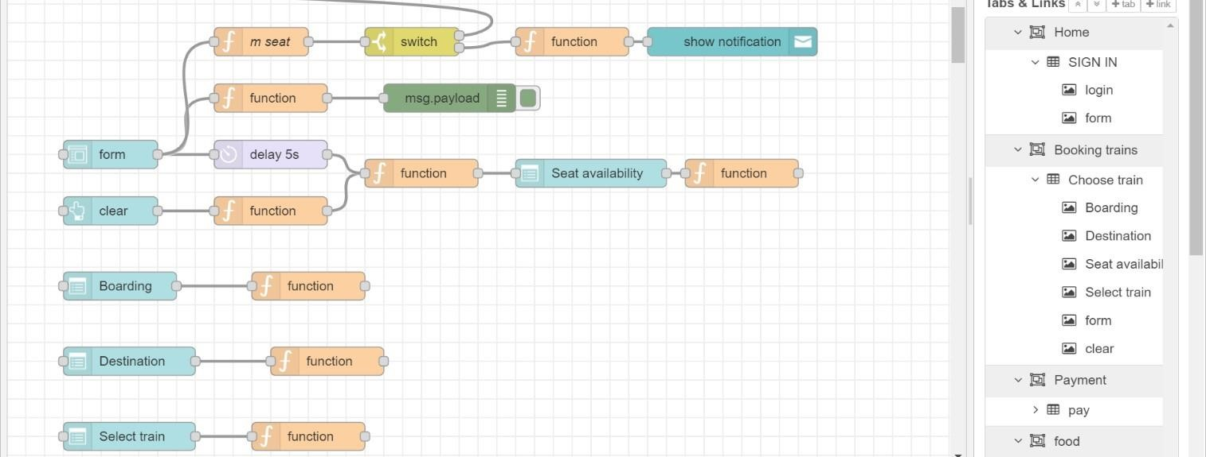

**FUNCTION NODE COMMAND TO INDICATE THE AVAILABLE SEATS:**

var a=global.get('a') var

s= []

for(let i=0;i<a.length==0;i++){ s.push(a[i]) }

if(s.length==0){

msg.options=[{"No seats available":0}]

}

else{

msg.options= s

}

msg.payload= s

return msg;

**FUNCTION NODE COMMAND TO CHOOSE THE AVAILABLE SEATS:**

var s=global.get('s') var

a=global.get('a') function reg(x){ for(let i=0;i<a.length;i++){ if(a[i]==x){

a.splice(i,1)

}

}

} if(s==1){

global.set('s1',s)

reg(s)

}

else if(s==2){

global.set('s2',s)

reg(s)

}

else if(s==3){

global.set('s3',s)

reg(s)

}

else if(s==4){

global.set('s4',s)

reg(s)

}

else if(s==4){

global.set('s4',s)

reg(s)

}

return msg;

**FUNCTION NODE COMMAND TO STORE DATA IN DATABASE:**

var m=global.get('m')

var d=new Date();

var utc=d.getTime()+(d.getTimezoneOffset()*60000); var

offset=5.5;

newDate=new Date(utc+(3600000*offset));

var n=newDate.toISOString() var date=n.slice(0,10) var time=n.slice(11,19)

var d1=date+','+time msg.payload={

"_id":d1,

"Name":m.Name,

"Age":m.Age,

"Mobile":m.Num,

"boarding":global.get('b'),

"destination":global.get('d'),

"Seat":global.get('s')

}

return msg;

**FORM DETAILS:**

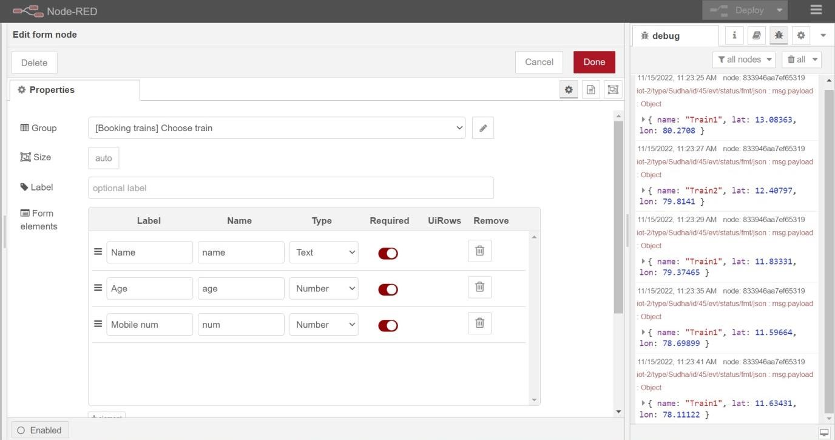

**SEAT DROPDOWN BOX:**

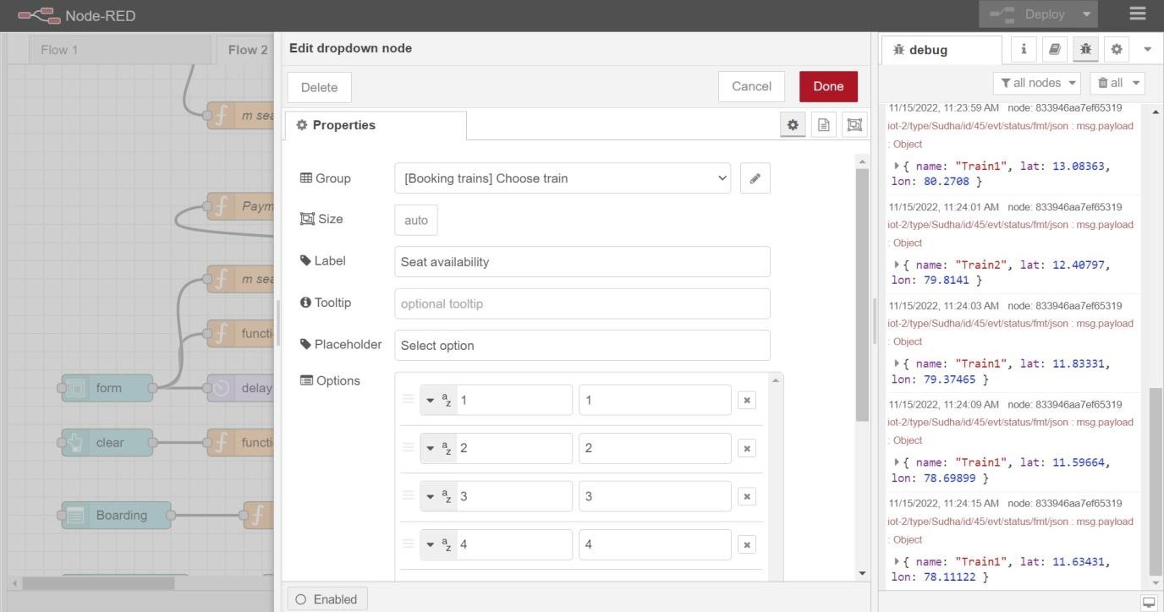

**WEB UI OUTPUT:**

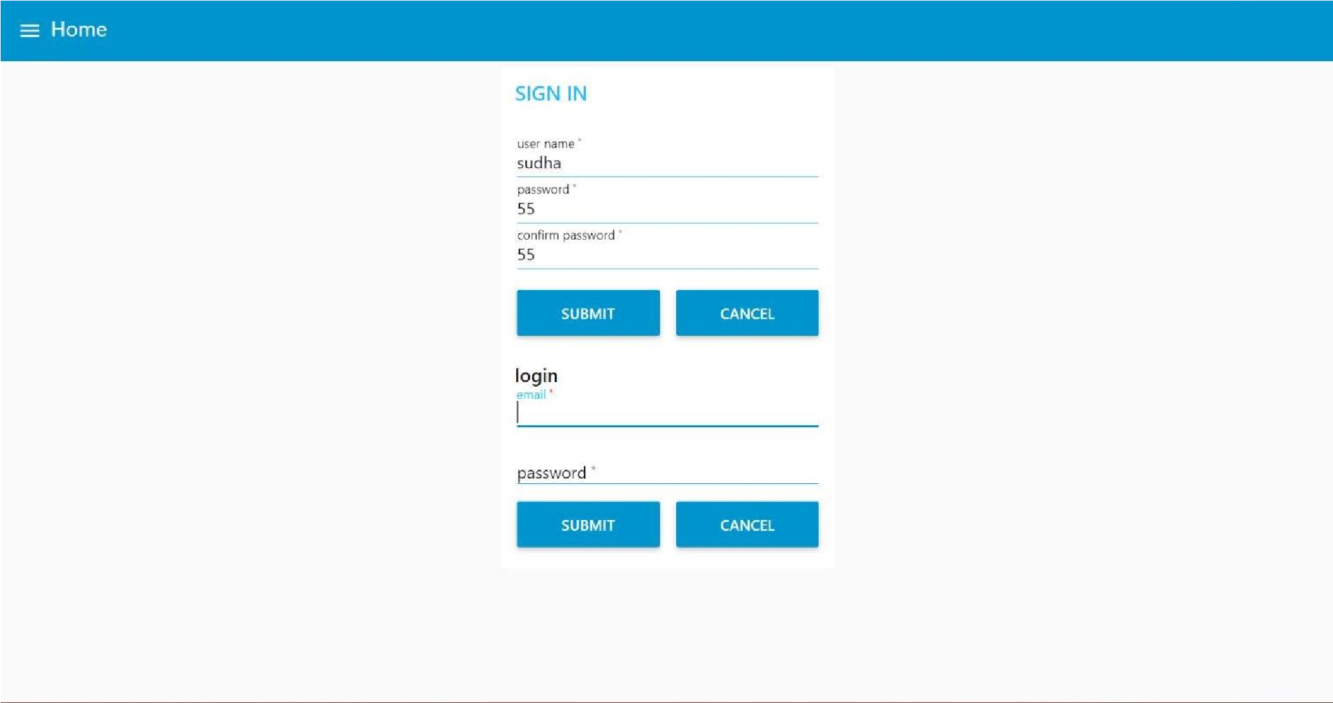

**WEB UI FOR TRAIN BOOKING:**

